NAME: G. Yashmita REG NO: 192511032
(RAPTOR)
EXPERIMENT 4:
The string is a sequence of characters placed in double quotes (” “).
Performing different operations on string data is called String
Handling. Strings are immutable. Whenever a change to a String is made,
an entirely new String is created. If we want to store a group of
characters we can use a char array. String provides various methods to
perform different operations on strings. Using Raptor draw a flowchart
to display the total number of characters in the string and returns it.

Aim
The objective of this experiment is to create a flowchart using RAPTOR to accept a string as input, calculate the total number of characters in the string, and display the result.

Software Requirements

Software: RAPTOR Flowchart Software
Operating System: Windows 10/11
Hardware: PC/Laptop
Input Device: Keyboard
Theory
RAPTOR is a graphical programming tool used to design algorithms using flowcharts. It allows users to develop logic without writing programming code. In this experiment, a string is accepted as input, and the built-in LengthOf() function is used to determine the total number of characters present in the string. The result is then displayed on the screen. This experiment helps understand string manipulation and the use of predefined functions in RAPTOR.

Procedure

Step 1:
Open the RAPTOR application and create a new flowchart.

Step 2:
Insert an Input symbol and prompt the user to enter a string.

Step 3:
Insert an Assignment symbol and use the LengthOf() function to calculate the total number of characters in the entered string.

Step 4:
Insert an Output symbol to display the message "The total number of characters is" along with the calculated length.
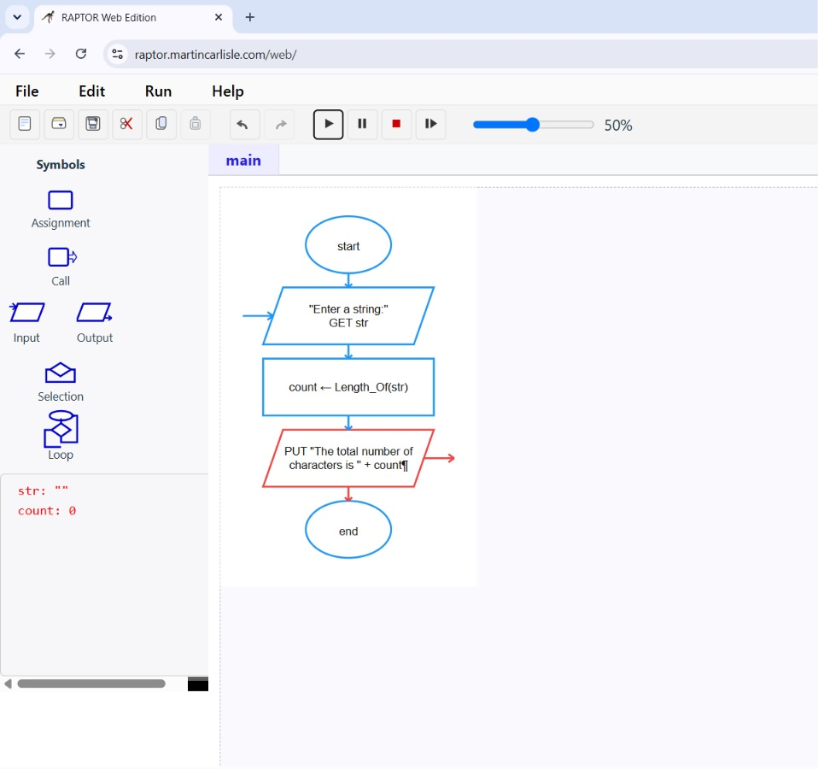
Figure 1. Displaying the Result.

Step 5:
Run the flowchart, enter different strings, and verify that the output displays the correct number of characters.
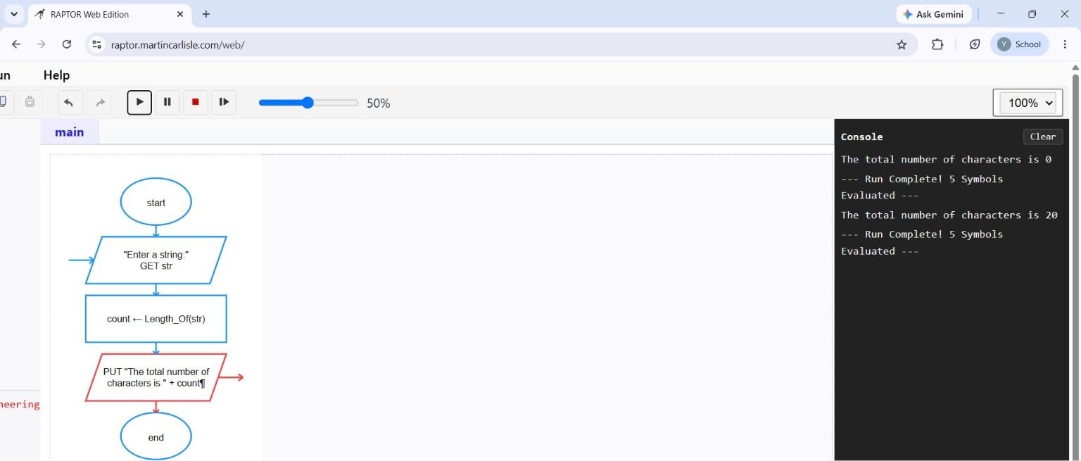
Figure 2. Executing the Flowchart.

Result
The flowchart was successfully created using RAPTOR to calculate the total number of characters in a given string. The program correctly accepted the input string, computed its length using the LengthOf() function, and displayed the result. The experiment demonstrated the use of string functions and flowchart-based programming for solving simple string-processing problems.

